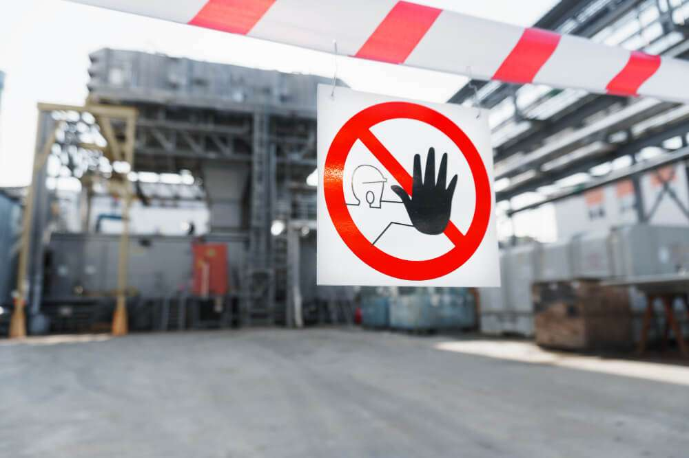
LO4 Safety Theory
PLEASE REMOVE ALL YELLOW HINTS BEFORE SUBMISSION
Akbar Qamar | [Date] | [Course title]

Contents
1. Introduction 3
2. Industrial Application Overview 4
2.1 Application description 4
2.2 Process sequence 4
3. Robotic Cell Design 6
3.1 Cell layout 6
3.2 Robot operating envelope 6
3.3 Operational modes 7
3.4 User interfaces 7
4. Safety Systems Used Within the Robotic Cell 8
4.1 Safety systems identification 8
4.2 Safety systems summary table 8
5. Safe Operation Analysis 10
5.1 How the systems ensure safe operation 10
5.2 Interaction between safety systems 10
5.3 Failure consequences 10
6. Hazards, Risks and Risk Reduction 12
6.1 Hazard identification 12
6.2 Risk assessment 12
6.3 Risk mitigation measures 13
7. Safe Working Plan 14
7.1 Safe working plan overview 14
7.2 Step-by-step safe working procedure 14
7.3 Maintenance and access safety 15
8. Legislation, Policies and Procedures 16
9. Evaluation of Safe Operation 17
10. Conclusion 18
Bibliography 19

No table of figures entries found.

1. Introduction
Write 3 to 5 lines introducing the report and the industrial robotic application.
You should explain:
- what robot or robotic cell is being investigated
- what industrial task it performs
- why safety and safe operation are important in this application
- what the report will cover
Suggested sentence starters:
- This report investigates the design and safe operation of a robot within an industrial application, with particular focus on safety systems, risk control and safe working procedures.
- The report examines how the robotic cell is designed, how safety systems are used, and how safe operation is ensured during production and maintenance.
- The investigation also includes a safe working plan and full risk assessment for the given production process.
Insert a system overview image or diagram showing:
- robot
- guarding
- operator area
- infeed and outfeed area
- emergency stop locations
- control panel
- safety devices

2. Industrial Application Overview

2.1 Application description
Write one short subsection describing the industrial application.
You should include:
- the industry sector
- the production task
- the role of the robot
- whether the process is loading, unloading, welding, pick-and-place, palletising, assembly, inspection or packaging
- why a robot is used instead of manual handling
Suggested prompts:
- The robotic cell is used in...
- The main function of the robot is to...
- The robot improves the process by...
- The cell requires safe operation because...

2.2 Process sequence
Write the robotic process as numbered steps, ideally 8 to 12 steps.
Example format:
- Operator starts the automated cycle from the control station.
- The PLC checks all safety conditions are healthy.
- The conveyor moves the workpiece into the robot loading zone.
- The robot moves to the pick position.
- The end effector grips the part.
- The robot transfers the part to the next position.
- A sensor confirms correct placement.
- The robot returns to home position.
- The next cycle begins automatically.
- If a safety device is triggered, the robot stops and enters a safe state.
Insert a flowchart showing:
- idle
- ready
- automatic cycle
- fault state
- manual mode
- emergency stop state

3. Robotic Cell Design

3.1 Cell layout
Investigate the layout of the robotic cell.
Write about:
- robot location
- operator access points
- material flow
- guarding arrangement
- maintenance access
- safe distances
- restricted zones
Insert a cell layout diagram with labels for:
- robot base
- operating envelope
- guard fencing
- interlocked gate
- operator panel
- emergency stop points
- safety scanner or light curtain
- loading and unloading areas

3.2 Robot operating envelope
Explain the operating envelope of the robot.
You should discuss:
- maximum reach
- sweep area
- movement zones
- hazards caused by arm movement
- safe separation from operators
Suggested sentence starters:
- The operating envelope refers to...
- The main hazard created by the operating envelope is...
- Safe cell design requires the working range to be...

3.3 Operational modes
Investigate the operational modes of the robot.
Include:
- automatic mode
- manual mode
- teach mode
- setup or maintenance mode
- reduced speed mode where relevant
For each mode, explain:
- who is allowed to use it
- what the robot is permitted to do
- what safety controls are required
Insert a simple table:
- mode
- purpose
- user access
- key safety control

3.4 User interfaces
Explain the user interfaces available in the robotic cell.
Examples:
- HMI screen
- operator push buttons
- teach pendant
- selector switch
- reset button
- emergency stop button
- stack light or alarm indicator
Write a short paragraph on why controlled access to user interfaces is important.

4. Safety Systems Used Within the Robotic Cell
This section is essential for P8.

4.1 Safety systems identification
Investigate the safety systems used within an industrial robotic cell.
Create a subsection or table for each of the following, if used:
- emergency stop system
- interlocked gates
- perimeter guarding
- light curtains
- laser area scanners
- safety mats
- enabling devices
- safety relays
- safe torque off
- two-hand control if relevant
- warning alarms and indicators
For each one, explain:
- what it is
- where it is located
- what hazard it controls
- what happens when it is activated
Suggested sentence starters:
- The robotic cell uses an emergency stop system to...
- Interlocked guarding prevents...
- A light curtain protects the operator by...
- Safety relays are used to...
Insert photos, product examples, or a labelled safety layout diagram.

4.2 Safety systems summary table
Create a table with these headings:
- safety device
- function
- hazard controlled
- effect on robot operation
- reset requirement

5. Safe Operation Analysis
This section is essential for M4.

5.1 How the systems ensure safe operation
Analyse how the systems in place ensure safe operation of the robotic cell.
Write 3 to 5 short paragraphs covering:
- prevention of unauthorised access
- safe stopping during faults or intrusions
- controlled restart after interruption
- safe maintenance intervention
- operator protection during automatic operation
- reduced-speed operation during teaching
Suggested sentence starters:
- Safe operation is ensured by a combination of...
- The guarding and interlock arrangement ensures that...
- Restart is controlled by...
- During maintenance, the system remains safe because...

5.2 Interaction between safety systems
Explain how safety systems work together rather than individually.
For example:
- interlocked gate sends signal to safety relay
- safety relay removes power to motion drive
- emergency stop overrides all operating modes
- HMI displays fault condition
- reset can only occur when the hazard is cleared
This section should show analysis, not just description.

5.3 Failure consequences
Write a short subsection explaining what could happen if safety systems were missing or failed.
Examples:
- collision
- crushing
- trapping
- unexpected restart
- unsafe manual intervention
- damage to tools, fixtures or product

6. Hazards, Risks and Risk Reduction

6.1 Hazard identification
Identify hazards associated with the robotic cell.
You should include:
- mechanical hazards
- electrical hazards
- trapping and crushing hazards
- impact hazards
- stored energy hazards
- maintenance hazards
- programming or control faults
- sensor failure or incorrect detection
- human error
Insert a hazard list or table.

6.2 Risk assessment
Design a full risk assessment for the given production process.
Use a table with headings such as:
- hazard
- who is at risk
- possible harm
- existing control measures
- likelihood
- severity
- risk rating
- further actions required
Suggested hazards:
- operator enters cell during automatic motion
- end effector drops component
- interlocked door bypassed
- unexpected restart after fault reset
- maintenance work during stored energy condition
- robot path error during teaching

6.3 Risk mitigation measures
Write short paragraphs explaining how risks are reduced.
Examples:
- perimeter guarding
- access control
- safe isolation
- lockout and tagout
- warning signage
- training
- preventive inspection
- validation of emergency stop and interlock functions

7. Safe Working Plan
This section is essential for D4.

7.1 Safe working plan overview
Design a safe working plan for the robotic cell in the production process.
Write a clear plan that covers:
- who may operate the cell
- start-up checks
- safe operating procedure
- fault response
- shutdown procedure
- isolation before maintenance
- restart after maintenance
- supervision and authorisation
Suggested sentence starters:
- Before production starts, the operator shall...
- The robot may only operate when...
- In the event of a fault...
- Maintenance work shall only begin after...
- Restart shall only be permitted when...

7.2 Step-by-step safe working procedure
Write the safe working plan as numbered steps.
Suggested structure:
- Inspect guarding, gates and warning devices.
- Check emergency stops and safety indicators.
- Confirm the work area is clear.
- Select the correct operating mode.
- Start the system from the authorised station.
- Monitor the cell during operation.
- Stop the system if abnormal movement or unsafe conditions occur.
- Isolate power before maintenance.
- Apply lockout and tagout.
- Test safe condition before re-entry.
- Remove tools and personnel from the cell.
- Recommission and restart in a controlled manner.

7.3 Maintenance and access safety
Write a short subsection on:
- maintenance access control
- isolation of electrical and pneumatic energy where relevant
- use of permits if appropriate
- use of teach mode or reduced-speed mode
- supervision of maintenance staff

8. Legislation, Policies and Procedures
Although LO4 focuses on investigation and safe operation, this section strengthens the report.
Write brief paragraphs on relevant areas such as:
- health and safety policy
- machine guarding requirements
- safe isolation
- training and competence
- emergency procedures
- risk assessment requirements
You do not need to overcomplicate this section. Keep it relevant to robotic cells.
Suggested wording:
- Relevant safety practice includes controlled access, emergency stop functionality, safe isolation, fault reporting and authorised restart procedures.
- The robotic cell must be operated in line with workplace health and safety procedures and documented risk controls.

9. Evaluation of Safe Operation
Write a short evaluative section answering:
- which safety measures are the most critical
- what the main remaining risks are
- whether the cell design is suitable for safe production use
- what improvements could further strengthen safety
Suggested sentence starters:
- The most important safety measure in this cell is...
- A limitation of the current safety arrangement is...
- Safe operation is improved by...
- A further improvement would be...

10. Conclusion
Write one concise concluding section that summarises:
- what was investigated
- the most important safety systems identified
- how safe operation is ensured
- why the safe working plan is necessary
Suggested sentence starter:
- In conclusion, the robotic cell can operate safely only when suitable safety systems, risk controls and structured working procedures are designed and applied together.

Bibliography
There are no sources in the current document.

